**Module: Study of Texts of Civilisation**

**Level: Third year English**

**Chapter Three**

**Lecture one : British Empire**

**British Empire**, a worldwide system of dependencies—[colonies](https://www.britannica.com/topic/Western-colonialism), protectorates, and other territories—that over a span of some three centuries was brought under the [sovereignty](https://www.merriam-webster.com/dictionary/sovereignty) of the crown of [Great Britain](https://www.britannica.com/place/Great-Britain-island-Europe) and the administration of the British government. The policy of granting or recognizing significant degrees of self-government by dependencies, which was favoured by the far-flung nature of the [empire](https://www.britannica.com/topic/empire-political-science), led to the development by the 20th century of the notion of a “British Commonwealth,” [comprising](https://www.merriam-webster.com/dictionary/comprising) largely self-governing dependencies that acknowledged an increasingly symbolic British sovereignty. The term was embodied in statute in 1931. Today the [Commonwealth](https://www.britannica.com/topic/Commonwealth-association-of-states) includes former elements of the British Empire in a free association of [sovereign](https://www.merriam-webster.com/dictionary/sovereign) states.

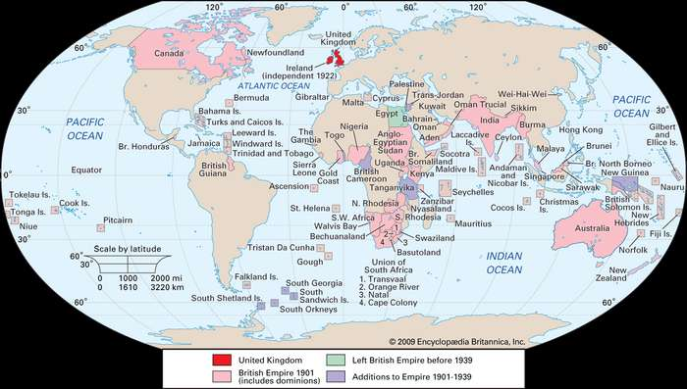

**Origins Of The British Empire**

Great Britain made its first tentative efforts to establish overseas settlements in the 16th century. Maritime expansion, driven by commercial ambitions and by competition with [France](https://www.britannica.com/place/France), accelerated in the 17th century and resulted in the establishment of settlements in [North America](https://www.britannica.com/place/North-America) and the [West Indies](https://www.britannica.com/place/West-Indies-island-group-Atlantic-Ocean). By 1670 there were British [American colonies](https://www.britannica.com/topic/American-colonies) in [New England](https://www.britannica.com/place/New-England), Virginia, and Maryland and settlements in the Bermudas, [Honduras](https://www.britannica.com/place/Honduras), Antigua, [Barbados](https://www.britannica.com/place/Barbados), and [Nova Scotia](https://www.britannica.com/place/Nova-Scotia). [Jamaica](https://www.britannica.com/place/Jamaica) was obtained by conquest in 1655, and the [Hudson’s Bay Company](https://www.britannica.com/topic/Hudsons-Bay-Company) established itself in what became northwestern [Canada](https://www.britannica.com/topic/history-of-Canada) from the 1670s on. The [East India Company](https://www.britannica.com/topic/East-India-Company) began establishing trading posts in [India](https://www.britannica.com/topic/history-of-India) in 1600, and the [Straits Settlements](https://www.britannica.com/place/Straits-Settlements) (Penang, [Singapore](https://www.britannica.com/place/Singapore), [Malacca](https://www.britannica.com/place/Melaka-Malaysia), and Labuan) became British through an extension of that company’s activities. The first permanent British settlement on the [African](https://www.britannica.com/place/Africa) continent was made at James Island in the [Gambia River](https://www.britannica.com/place/Gambia-River) in 1661. Slave trading had begun earlier in [Sierra Leone](https://www.britannica.com/place/Sierra-Leone), but that region did not become a British possession until 1787. [Britain](https://www.britannica.com/place/United-Kingdom) acquired the [Cape of Good Hope](https://www.britannica.com/place/Cape-of-Good-Hope) (now in South Africa) in 1806, and the South African interior was opened up by [Boer](https://www.britannica.com/topic/Boer-people) and British pioneers under British control.

[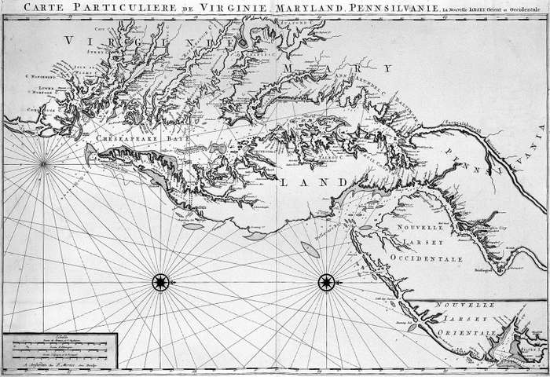](https://cdn.britannica.com/99/70199-050-AEA3D696/Detail-map-colonies-Maryland.jpg)

**Maryland colony**

Map of Maryland colony.

*Library of Congress, Washington, D.C.*

Nearly all these early settlements arose from the enterprise of particular companies and magnates rather than from any effort on the part of the English crown. The crown exercised some rights of appointment and supervision, but the colonies were essentially self-managing enterprises. The formation of the empire was thus an unorganized process based on piecemeal acquisition, sometimes with the British government being the least willing partner in the enterprise.

In the 17th and 18th centuries, the crown exercised control over its colonies chiefly in the areas of trade and shipping. In accordance with the mercantilist philosophy of the time, the colonies were regarded as a source of necessary raw materials for [England](https://www.britannica.com/place/England) and were granted monopolies for their products, such as tobacco and sugar, in the British market. In return, they were expected to conduct all their trade by means of English ships and to serve as markets for British manufactured goods. The [Navigation Act](https://www.britannica.com/event/Navigation-Acts) of 1651 and subsequent acts set up a closed economy between Britain and its colonies; all colonial exports had to be shipped on English ships to the British market, and all colonial imports had to come by way of England. This arrangement lasted until the combined effects of the Scottish economist [Adam Smith](https://www.britannica.com/biography/Adam-Smith)’s *Wealth of Nations* (1776), the loss of the American colonies, and the growth of a free-trade movement in Britain slowly brought it to an end in the first half of the 19th century.

The [slave trade](https://www.britannica.com/topic/slave-trade) acquired a peculiar importance to Britain’s colonial economy in the Americas, and it became an economic necessity for the Caribbean colonies and for the southern parts of the future [United States](https://www.britannica.com/place/United-States). Movements for the end of [slavery](https://www.britannica.com/topic/slavery-sociology) came to fruition in British colonial possessions long before the similar movement in the United States; the trade was abolished in 1807 and slavery itself in Britain’s dominions in 1833.

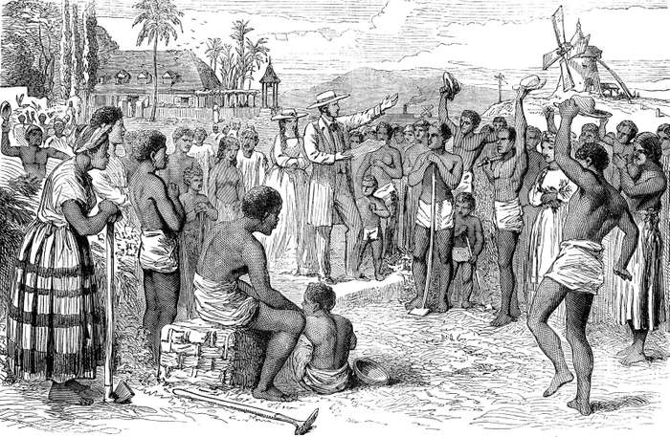

**Competition With France**

British military and naval power, under the leadership of such men as [Robert Clive](https://www.britannica.com/biography/Robert-Clive), [James Wolfe](https://www.britannica.com/biography/James-Wolfe), and [Eyre Coote](https://www.britannica.com/biography/Eyre-Coote), gained for Britain two of the most important parts of its empire—Canada and India. Fighting between the British and French colonies in North America was [endemic](https://www.merriam-webster.com/dictionary/endemic) in the first half of the 18th century, but the [Treaty of Paris](https://www.britannica.com/event/Treaty-of-Paris-1763) of 1763, which ended the [Seven Years’ War](https://www.britannica.com/event/Seven-Years-War) (known as the [French and Indian War](https://www.britannica.com/event/French-and-Indian-War) in North America), left Britain dominant in Canada. In India, the East India Company was confronted by the French [Compagnie des Indes](https://www.britannica.com/topic/French-East-India-Company), but [Robert Clive](https://www.britannica.com/biography/Robert-Clive)’s military victories against the French and the rulers of [Bengal](https://www.britannica.com/place/Bengal-region-Asia) in the 1750s provided the British with a massive accession of territory and ensured their future supremacy in India.

The loss of Britain’s 13 American colonies in 1776–83 was compensated by new settlements in [Australia](https://www.britannica.com/place/Australia) from 1788 and by the spectacular growth of [Upper Canada](https://www.britannica.com/place/Canada-West) (now [Ontario](https://www.britannica.com/place/Ontario-province)) after the emigration of loyalists from what had become the United States. The [Napoleonic Wars](https://www.britannica.com/event/Napoleonic-Wars) provided further additions to the empire; the [Treaty of Amiens](https://www.britannica.com/event/Treaty-of-Amiens-1802) (1802) made Trinidad and Ceylon (now [Sri Lanka](https://www.britannica.com/place/Sri-Lanka)) officially British, and in the Treaty of Paris (1814) France ceded Tobago, [Mauritius](https://www.britannica.com/place/Mauritius), [Saint Lucia](https://www.britannica.com/place/Saint-Lucia), and [Malta](https://www.britannica.com/place/Malta). Malacca joined the empire in 1795, and Sir [Stamford Raffles](https://www.britannica.com/biography/Stamford-Raffles) acquired Singapore in 1819. Canadian settlements in Alberta, Manitoba, and [British Columbia](https://www.britannica.com/place/British-Columbia) extended British influence to the Pacific, while further British conquests in India brought in the [United Provinces](https://www.britannica.com/place/Dutch-Republic) of Agra and Oudh and the Central Provinces, East Bengal, and Assam.

Retrieved from : https://www.britannica.com/place/British-Empire