**Module :ESP *Approaches to ESP Course Design***

1- **Definitions**

**Course**

A Course could be defined simply as a series of lessons.

ESP Course design is the process by which the raw data about a learning need is interpreted in order to produce an integrated series of teaching-learning experiences, whose ultimate aim is to lead the learners to a particular state of knowledge.

**Syllabus**

Syllabus is most often defined as specifications of content to be taught in a course, and is concerned with course objectives (Dubin & Olshtain, 1986; Jordan, 1997; Nunan, 1988; Richards, 2001). In this respect, it is clear that a syllabus is limited to particular subject of a particular class.

**Curriculum**

According to Allen (1984, p.64), Curriculum is “a very general concept involving consideration of the whole complex of philosophical, social, and administrative factors which contribute to the planning of an education programme”. From this definition it is ostensible that curriculum is a wider concept as compared with syllabus, so that it includes everything about learning/teaching processes.

**2-Approaches to ESP Course Design**

Course design involves putting the theoretical decisions about objectives and into a context. Robinson (1991:41). Yet different approaches to course formation have been formulated by different designers. Hence,Hutchinson and Waters (1987) have formulated the following approaches to course design:

1. Language-centred course design

2. Skills-centred

3. Learning-centred.

**2.1- Language-centred Course Design**

“Its starts from the learners and their needs, and thus it might be considered a learner-centred approach, but it is, in fact, not learner-centred in any meaningful sense of the term”. Hutchinson and Waters (1987:66).

They added that: “we must, however, avoid the mistake made by the Audio lingual Approach of believing that because language has been describable system, describing that system will induce systematic learning”. (ibid)

In fact, language description doesn’t mean its learning. The language teacher has traditionally looked to the linguist and grammarian for guidance. He has adopted the linguist’s categories of language description and used them as categories of instruction. Mackay and Mountford (1978:15)

Hence, Hutchinson and Waters (1987) criticised the approach as beingnot learner-centred, but simply learner-restricted. They added that: “the language-centred process can also be criticised for being a static and inflexible procedures, which can take little account of the conflicts and contradictions that are inherent in any human endeavour”. Hutchinson and Waters (1987:67)

Language- centred approach is the simplest and more familiar kind to English teachers. It is an approach that focuses on the linguistic performance of the learner in the target situation (Hutchinson and Waters, 1987: 65).

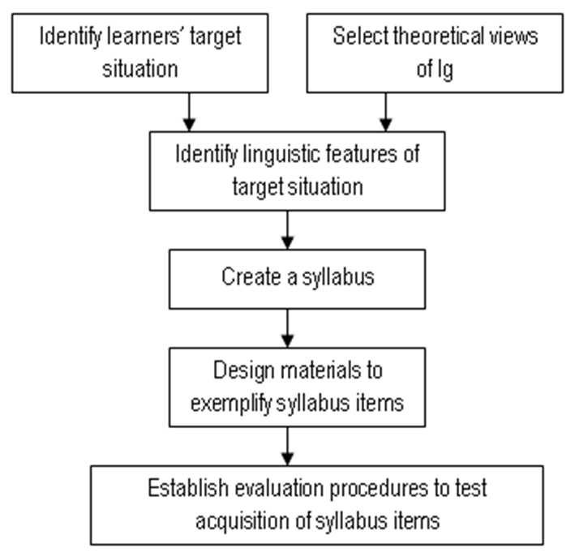

**Figure 1. A language-centred approach to course design Hutchinson & Waters (1987)**

**2. 2 Skills-centred Approach to Course Design**

The skills-centred approach is found on two fundamental principles, one theoretical, the other pragmatic. Hutchinson and Waters (1987)

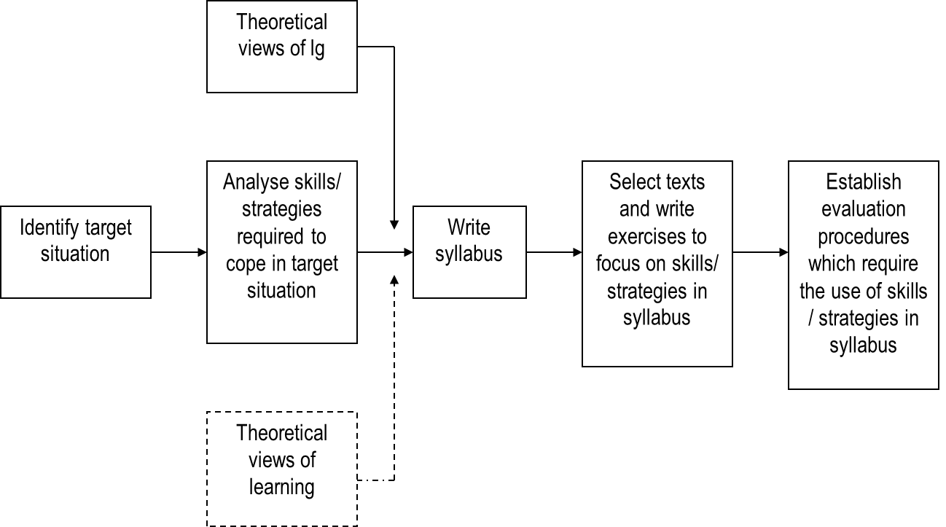

**Figure 2: A skills-centred approach to course design Hutchinson & Waters (1987)**

For them, the theoretical hypothesis is the one based on the use of learning strategies from the part of the learners in order to process information.

Moreover, the pragmatic hypothesis is based on the distinction made by Widdowson (1981) between goal-oriented courses and process –oriented courses. Yet, the process oriented approach is defined by Holmes (1982) as:

The process-oriented approach…. Is at least realistic in concentrating on strategies and processes of making students aware of their own abilities and potential, and motivating them to tackle texts on their own after the end of the course, so that they can continue to improve.

In other words, the skills-centred approach sees ESP course as helping learners to develop skills and strategies which will continue to develop after the ESP course itself. Its aim is not to provide a specific corpus of linguistic knowledge but to make the learners into better processors of information (Hutchinson and Waters).

All in all, this can be summarised within the principles of learner centeredness which as Clark (1987) sees in his educational philosophy as leading to an emphasis on *process* rather than *product*, a focus on learner differences, learner strategies, and learner self-direction and autonomy.

Therefore, according to Tom Hutchinson and Alan Waters (1987), the role of needs analysis in a skill-centred approach is twofold.

* It works as a basis for pinpointing the learner’s competence that enables them to achieve a linguistic competence in the target situation.
* It highlights the learner’s capabilities and abilities in ESP classrooms for the course designer.

Yet, the skill-centred approach is criticised as being the learner as a user of language rather than a learner of language

**2.3 A learning-centred Approach to Course Design**

A learning-centred course differs from a traditional teaching-centred (language /skills centred) course in several ways (Weimer, 2002).

First, the balance of control in a learning-centred class will change. What does this mean? A common belief is that in a teaching,-centred environment, where teachers are seen to be the only source of information and are likely authoritative, the feeling of responsibility for learning is higher. This is why, in case some students‟ fail to learn, teachers blame themselves because they believe that good learning depends entirely on good teaching. Consequently, teaching-centred courses designers ensure control over many aspects of the course.

In contrast, in a learning-centred situation, students are ultimately responsible for their own learning using different strategies. For example they have to engage in assigned learning activities and exert the effort required to learn. So if students are supposed to take responsibility for their own learning, it is time to give them more control over the way learning experiences are structured. In addition to this, teachers delivering a learning-centred need to control aspects of the course to ensure that they meet their professional responsibility to create a course that addresses certain learning outcomes. In the same line, students need to control aspects of the learning environment to meet individual learning goals and maintain motivation.

The idea behind this approach is that the learner is the main actor in the learning process for this to happen it takes the following principles:

1. Learning is totally determined by the learner who uses his knowledge and skills to make sense of new information.
2. Learning is not just a mental process; it is a process of negotiation between individuals and society.
3. Course design is negotiation process in which both the target situation influences the features of the syllabus and also it's a dynamic process in which means and recourses vary from time to time.

Despite the fact of being: a language, learning, or skills- centred approach; making the ESP course as dynamic and flexible as much as possible is the most important thing. Hence, a clear understanding of students‟ needs and the demands of the target situation will serve in developing the appropriate materials and methodologies needed to function effectively in a given domain.

# REFERENCES

* Dudley-Evans,T.and St Johns,M.J (1998) *Developments in ESP a Multi- Disciplinary Approach* Cambridge: Cambridge University Press.
* Flook, D. (1993). “Are the Authentic Materials a Pre-requisite for an ESP Course”. The ESP Maghreb Conference. The British Council: London. *
* Hutchinson, T. and Waters, A. (1987). *English for Specific Purposes.* Cambridge: CUP
* Ricards, J., J.Platt, & H. Weber. (1992). Longman Dictionary of Applied Linguistics. London: Longman.
* Richards, J.C (2001) *Approaches and Methods in Language Teaching* 2nd Edition Cambridge: Cambridge University Press.
* Robinson, P (1991) *ESP today*.UK: Prentice Hall International ltd.
* Weimer, M. (2002). Learner-centered teaching: five key changes to practice. San Francisco, CA: JosseyBass.