Pronunciation of the final S

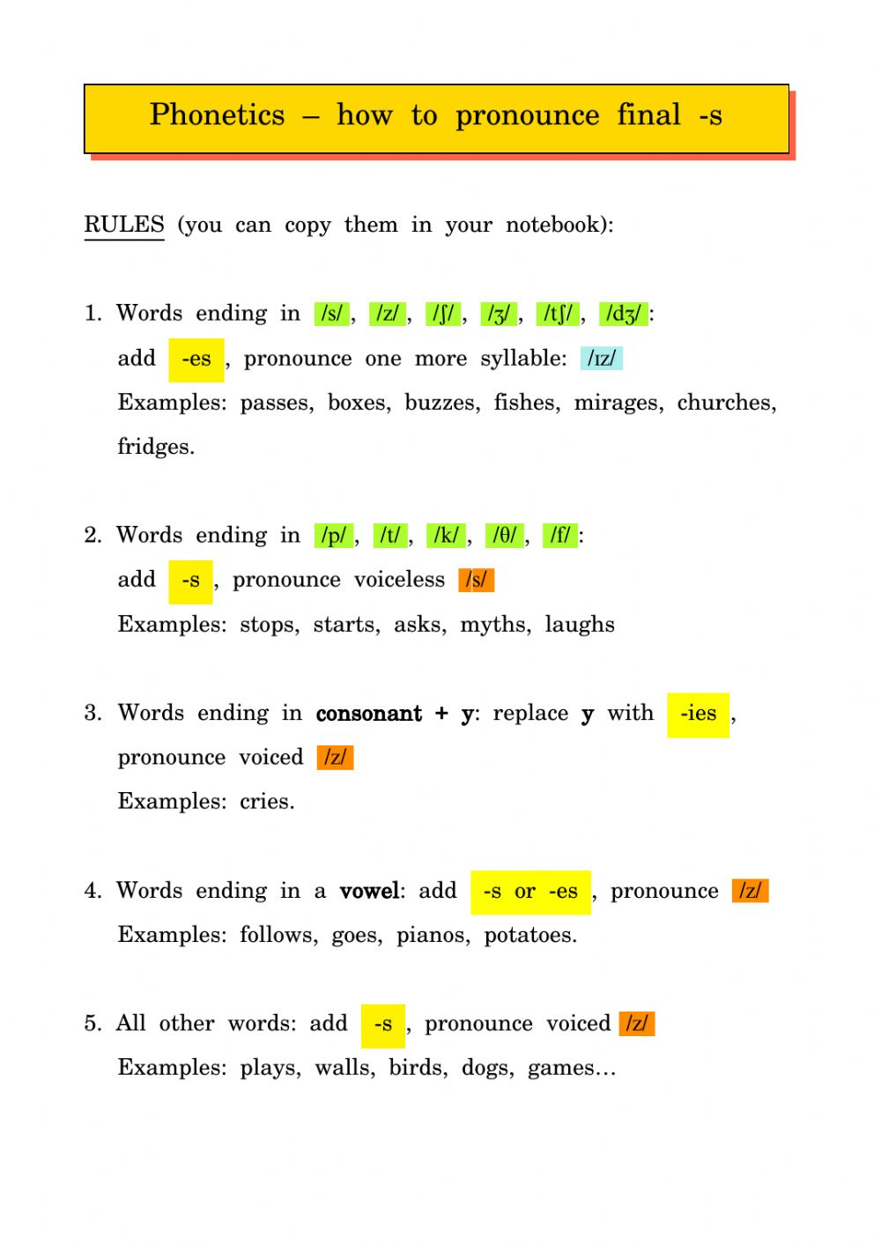

Activity:
/S/ | /Z/ | /IZ/
Hurts  Likes  Stops | Cows  Drives  Dries | Prizes  Boxes  ages

