Module : Culture(s)/ Civilization(s)
Academic year : 2021-2022
Lecture two: family life in Britain
- Definition:
What is family life like in Britain ?

Changing Values and Norms of the British Family

The family in Britain is changing. The once typical British family headed by two parents has undergone substantial changes during the twentieth century. In particular there has been a rise in the number of single-person households, which increased from 18 to 29 per cent of all households between 1971 and 2002. By the year 2020, it is estimated that there will be more single people than married people. Fifty years ago this would have been socially unacceptable in Britain.

In the past, people got married and stayed married. Divorce was very difficult, expensive and took a long time. Today, people's views on marriage are changing. Many couples, mostly in their twenties or thirties, live together (cohabit) without getting married. Only about 60% of these couples will eventually get married.

In the past, people married before they had children, but now about 40% of children in Britain are born to unmarried (cohabiting) parents. In 2000, around a quarter of unmarried people between the ages of 16 and 59 were cohabiting in Great Britain. Cohabiting couples are also starting families without first being married. Before 1960 this was very unusual, but in 2001 around 23 per cent of births in the UK were to cohabiting couples.

People are generally getting married at a later age now and many women do not want to have children immediately. They prefer to concentrate on their jobs and put off having a baby until late thirties.

The number of single-parent families is increasing. This is mainly due to more marriages ending in divorce, but some women are also choosing to have children as lone parents without being married.

There are many and varied types of family in the UK.
- Nuclear family - a family unit consisting of two adults and any number of children living together. The children might be biological, step or adopted.
- Extended family - grandparents, aunts, uncles, and cousins, either all living nearby or within the same household, eg if a married couple lives with either the husband or wife's parents, the family changes from a nuclear to extended household.
- Reconstituted family - also known as a 'step family'. A family where one or both adults have children from previous relationships living with them.
- Single parent family - consists of a parent not living with a partner, who has most of the day-to-day responsibilities for raising the children. The children will live with this single parent for the majority of the time but may still have contact with their other parent.
- Same-sex family - since civil partnerships were legalised in 2005, the number of same sex families has been growing (same-sex marriage was legalised in 2014). Same-sex couples cannot conceive together, so their children may be adopted or be the biological children of one member of the couple. They may also be from a sperm donor or a surrogate birth mother.
Family Size

On average 2.4 people live as a family in one home Britain. This is smaller than most other European countries.

Cost of loving:
he cost of living varies from one part of the UK to another. Generally it is more expensive to live in London and the south-east of England, and cheaper up north.
Britain's currency is based on the pound sterling (£) which is divided into one hundred pence (100p).

Housing:

Most people in England live in urban areas. Towns and cities are spreading into their surrounding environment to cope with the increase populations. In England, an average of 7,000 hectares of farmland, countryside and green space were converted to urban use every year between 1985 and 1998. This is almost the equivalent size of 9,600 international football pitches!
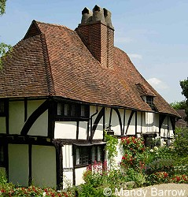This house is over 600 years old
Who owns houses in England?
More people are buying their own homes than in the past. About two thirds of the people in England and the rest of Britain either own, or are in the process of buying, their own home. Most others live in houses or flats that they rent from a private landlord, the local council, or housing association.
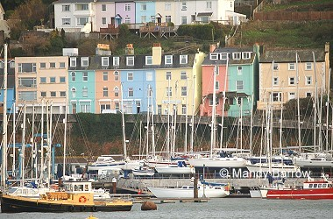
People buying their property almost always pay for it with a special loan called a mortgage, which they must repay, with interest, over a long period of time, usually 25 years.
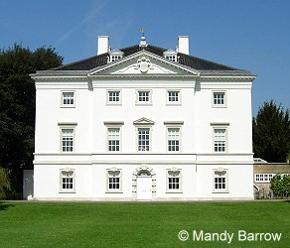
What are houses in England like?
Most houses in England are made of stone or brick from the local area where the houses are built. The colours of the stones and bricks vary across the country.
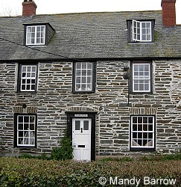 | 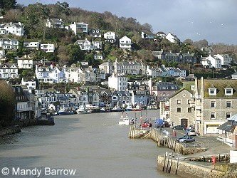
Types of houses in England
England has many types of homes. In the large cities, people often live in apartments, which are called flats. In most towns, there are streets of houses joined together in long rows. They are called terraced houses.
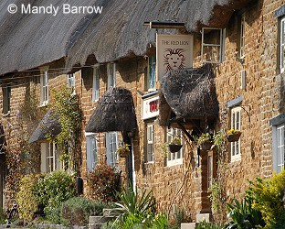
The main types of houses in England are:
- Detached (a house not joined to another house)
- Semi-detached (two houses joined together)
- Terrace (several houses joined together)
- Flats (apartments)
Photos of the different types of houses
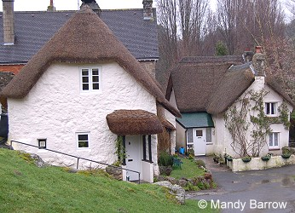
Census 2001: Housing

